DFDS

Context level Diagram:

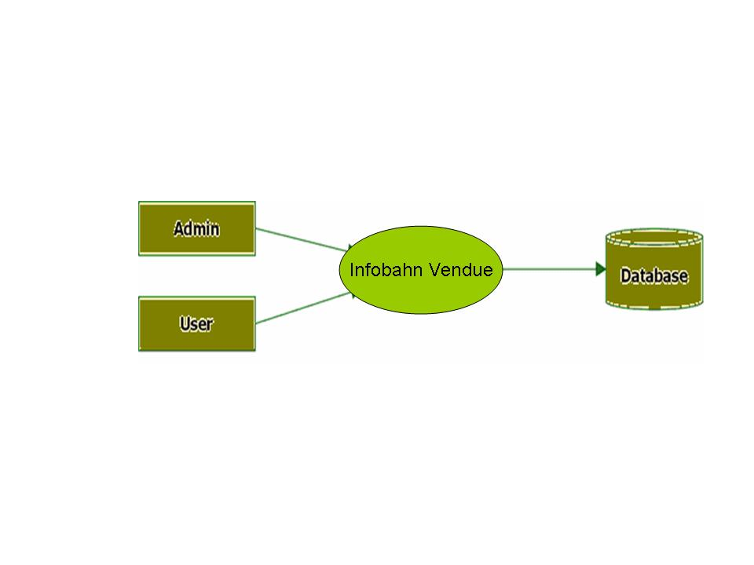

Level 0 DFD for Admin:

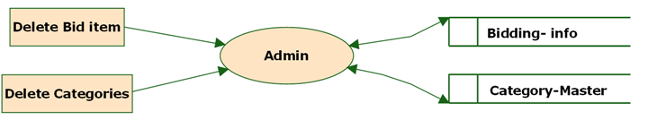

Level 0 DFD for user:

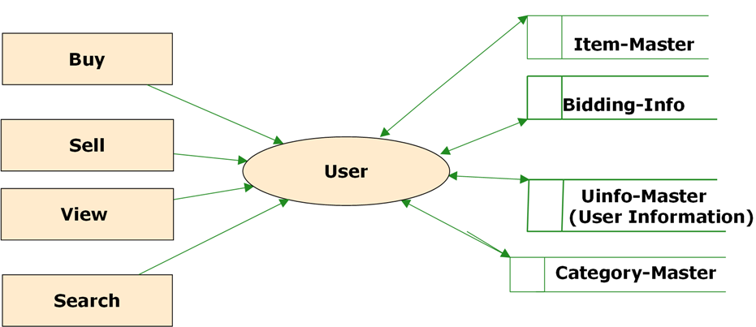

Level 1 DFD for View of (User):

